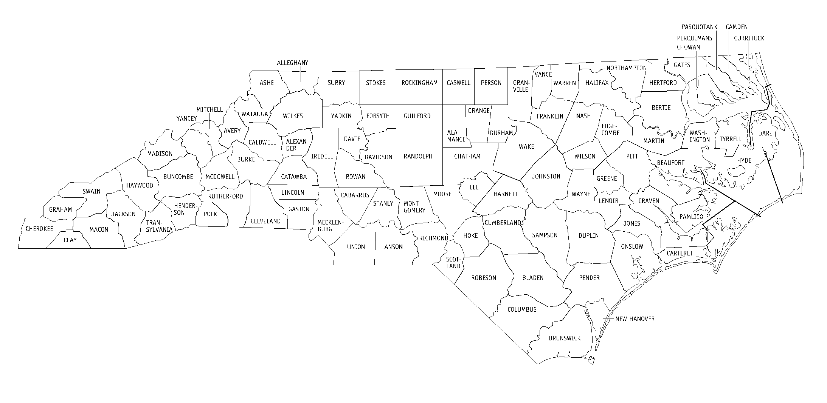
Legal Aid of NC Offices













































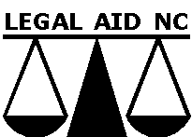

A – Legal Aid of NC – Sylva Office
1286 West Main Street, Sylva, NC 28779
828-586-893; 800-458-6817

B – Legal Aid of NC – Asheville Office
184 East Chestnut, Asheville, NC 28801
828-236-1080; 877-439-3480

C – Legal Aid of NC – Morganton Office
211 East Union Street, Morganton, NC 28655
828-437-8280; 800-849-5195

D – Legal Aid of NC – Boone Office
171 Grand Boulevard, Boone, NC 28607
828-264-5640; 800-849-5666

E – Legal Aid of NC – Gastonia Office
111 East Third Avenue, Suite 200,
Gastonia, NC 28052
704-865-2357; 800-230-5812
F – Legal Aid of NC – Charlotte Office
1431 Elizabeth Avenue, Charlotte, NC 28204
704-971-2621; 800-738-3868

G – Legal Aid of NC – Concord Office
133 Union Street South, Concord, NC 28025
704-786-4145; 877-439-3480

H – Legal Aid of NC – Monroe Office
100 West Jefferson Street, Monroe, NC 28110
704-283-2172; 877-439-3480

I – Legal Aid of NC – Winston-Salem Office
102 West Third Street, Suite 305
Winston-Salem, NC 27101
336-725-9162; 866-472-4243

J – Legal Aid of NC – Greensboro Office
122 North Elm Street, Suite 700
Greensboro, NC 27401
336-272-0148; 800-951-2257
K – Legal Aid of NC – Fayetteville Office
157 Gillespie Street, Fayetteville, NC 28302
910-483-0400; 800-824-5340

L – Legal Aid of NC – Pembroke Office
101 East Second Street, Pembroke, NC 28372
910-521-2831; 800-554-7852

M – Legal Aid of NC – Durham Office
201 West Main St., Ste. 400 Durham, NC 27702
919-688-6396; 800-331-7594

N – Legal Aid of NC – Pittsboro Office
959 East Street, Ste. A&B, Pittsboro, NC 27312
919-542-0475; 800-672-5834

O – Legal Aid of NC – Raleigh Office
224 South Dawson Street, Raleigh, NC 27601
919-828-4647
P – Legal Aid of NC – Sanford Office
133 South Horner Boulevard, Suite 8
Sanford, NC 27330
919-774-6241

Q – Legal Aid of NC – Smithfield Office
312 South Third St., Smithfield, NC 27577
919-934-5027; 800-682-1016

R – Legal Aid of NC – Wilson Office
409 North Goldsboro St., Wilson, NC 27893
252-291-6851; 800-682-7902

S – Legal Aid of NC – Rocky Mount Office
148 South Washington Street, Suite 105
Rocky Mount, NC 27802-0388
252-442-0635; 800-682-7902

T – Legal Aid of NC – Goldsboro Office
102-A South William Street
Goldsboro, NC 27530
919-731-2800; 800-682-7902
U – Legal Aid of NC – Ahoskie Office
610 East Church Street, Ahoskie, NC 27810
252-332-5124; 800-682-0010

V – Legal Aid of NC – Greenville Office
427 South Evans Street, Greenville, NC 27858
252-758-0113; 800-682-4592

W – Legal Aid of NC – New Bern Office
213 Pollack Street, New Bern, NC 28560
252-637-9502; 800-672-8213

X – Legal Aid of NC – Wilmington Office
201 North Front Street, Suite 1002,
Wilmington, NC 28402
910-763-6207; 800-672-9304

LANC Statewide Projects:

Advocates for Children’s Services
201 West Main St., Ste. 400 Durham, NC 27702
919-266-0051; ACSinfo@legalaidnc.org

Domestic Violence Initiative
224 S. Dawson Street, Raleigh, NC
919-856-2142; DVIinfo@legalaidnc.org

Environmental Poverty Law Project
122 North Elm Street, Suite 700
Greensboro, NC 27401
336-272-0148; 800-951-2257

Farmworker Unit, Legal Aid of NC
224 S. Dawson Street, Raleigh, NC
919-856-2180; 800-777-5869

